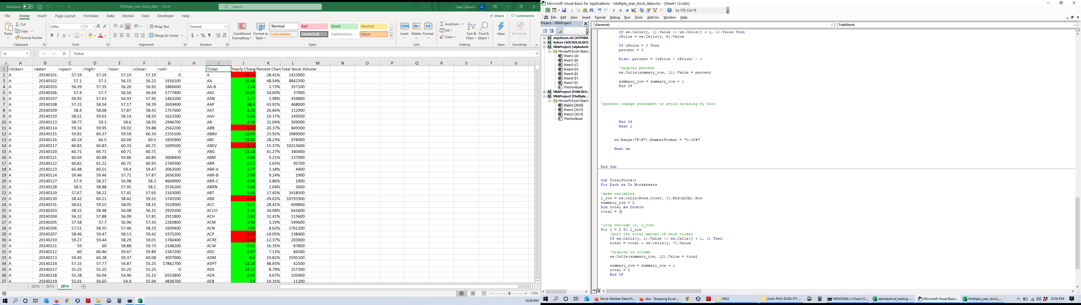

Sub headers()

For Each ws In Worksheets

'naming headers

ws.Cells(1, 9).Value = "Ticker"

ws.Cells(1, 10).Value = "Yearly Change"

ws.Cells(1, 11).Value = "Percent Changed"

ws.Cells(1, 12).Value = "Total Stock Volume"

Next ws

End Sub

Sub SetTicker()

For Each ws In Worksheets

summary_row = 2

Dim ticker As String

l_row = ws.Cells(Rows.Count, 1).End(xlUp).Row

'first ticker

ticker = 0

For j = 2 To l_row

'while the row is not the ticker, next otherwise

If ws.Cells(j, 1).Value <> ws.Cells(j - 1, 1) Then

ticker = ws.Cells(j, 1).Value

'change the ticker to the newly found value

ws.Cells(summary_row, 9) = ticker

'set the next ticker

summary_row = summary_row + 1

End If

Next j

Next ws

End Sub

Sub YearlyDifference()

For Each ws In Worksheets

l_row = ws.Cells(Rows.Count, 1).End(xlUp).Row

summary_row = 2

Dim oPrice As Double

Dim cPrice As Double

Dim yearlyChange As Double

'for each ticker

For j = 2 To l_row

'find openPrice

If ws.Cells(j, 1).Value <> ws.Cells(j - 1, 1) Then

oPrice = ws.Cells(j, 3).Value

End If

'find close price

If ws.Cells(j, 1).Value <> ws.Cells(j + 1, 1) Then

cPrice = ws.Cells(j, 6).Value

'formula to calculate yearly

yearlyChange = cPrice - oPrice

'display yearly total

ws.Cells(summary_row, 10).Value = yearlyChange

'set the next ticker

summary_row = summary_row + 1

End If

Next j

Next ws

End Sub

Sub ConditionalFormatting()

For Each ws In Worksheets

l_row = ws.Cells(Rows.Count, 1).End(xlUp).Row

For j = 2 To l_row

'conditional formatting

If ws.Cells(j, 10).Value > 0 Then

ws.Range("J" & j).Interior.ColorIndex = 4

ElseIf ws.Cells(j, 10).Value < 0 Then

ws.Range("J" & j).Interior.ColorIndex = 3

Else: ws.Range("J" & j).Interior.ColorIndex = 2

End If

Next j

Next ws

End Sub

Sub PercentChanged()

For Each ws In Worksheets

l_row = ws.Cells(Rows.Count, 1).End(xlUp).Row

summary_row = 2

Dim oPrice As Double

Dim cPrice As Double

Dim percent As Double

For j = 2 To l_row

'find openPrice

If ws.Cells(j, 1).Value <> ws.Cells(j - 1, 1).Value Then

oPrice = ws.Cells(j, 3).Value

End If

'find close price

If ws.Cells(j, 1).Value <> ws.Cells(j + 1, 1).Value Then

cPrice = ws.Cells(j, 6).Value

If oPrice = 0 Then

percent = 0

Else: percent = (cPrice / oPrice) - 1

'display percent

ws.Cells(summary_row, 11).Value = percent

summary_row = summary_row + 1

End If

'percent change statement to avoid dividing by Zero

End If

Next j

ws.Range("K:K").NumberFormat = "0.00%"

Next ws

End Sub

Sub TotalStock()

For Each ws In Worksheets

'make variables

l_row = ws.Cells(Rows.Count, 1).End(xlUp).Row

summary_row = 2

Dim total As Double

total = 0

'loop through (j, l_row)

For j = 2 To l_row

'pull the total amount of each ticker

If ws.Cells(j, 1).Value <> ws.Cells(j + 1, 1) Then

total = total + ws.Cells(j, 7).Value

'display in column

ws.Cells(summary_row, 12).Value = total

summary_row = summary_row + 1

total = 0

End If

Next j

Next ws

End Sub